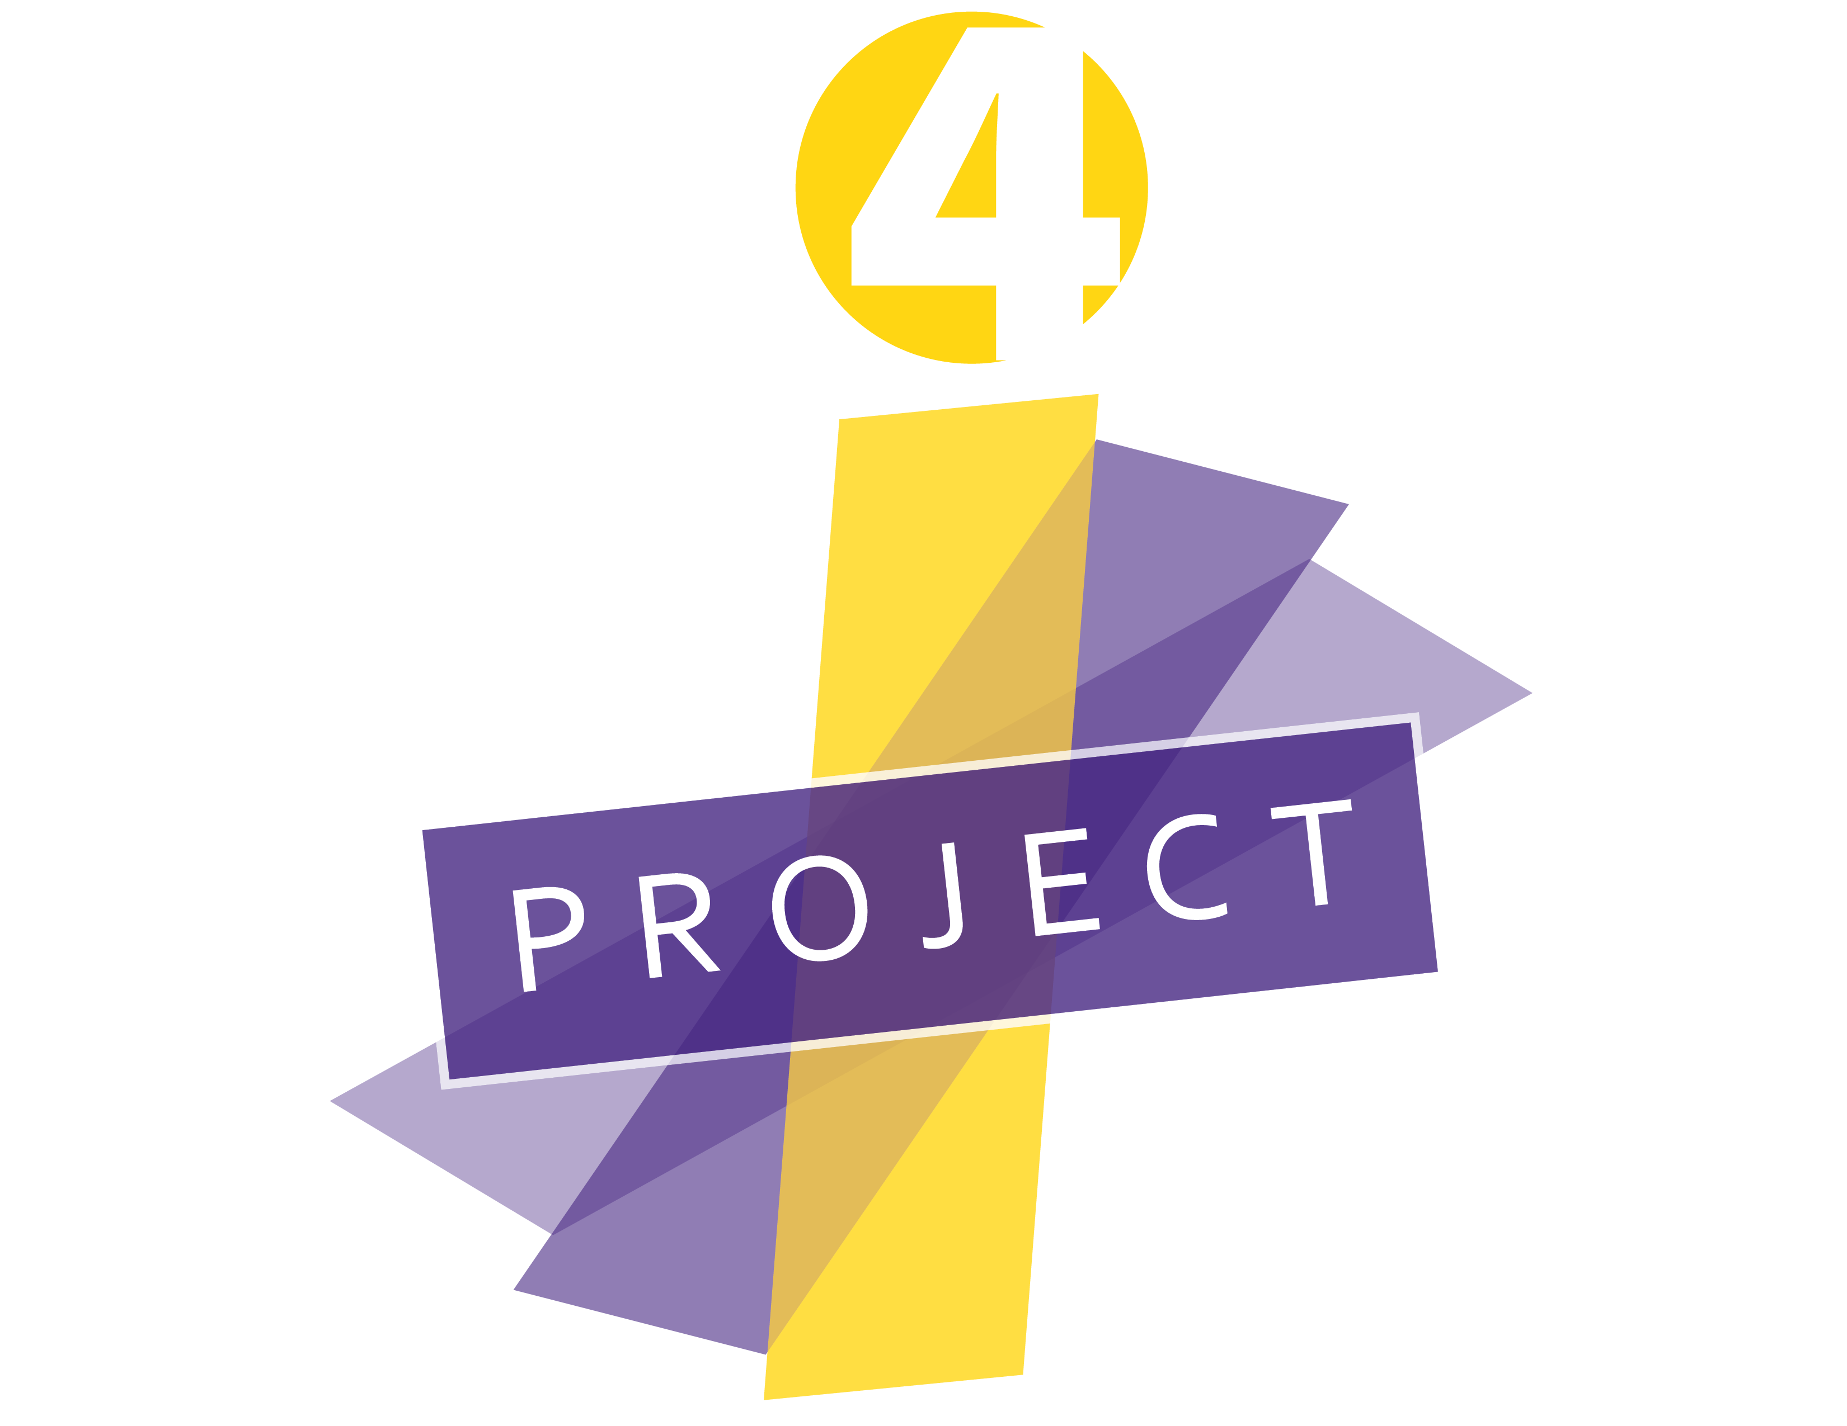 

**LEARNING EXCHANGE PROTOCOL**

**ACADEMIC DISCOURSE OBSERVATION TOOLS, Part II**

***Naming Practice with Selective Verbatim Observation Notes***

Step One:

*Watch the classroom video and take notes on what you are seeing*

|  |  |  |
| --- | --- | --- |
| **Time Stamp** | **Observations** | **Notes** |
|  |  |  |
|  |  |  |
|  |  |  |
|  |  |  |
|  |  |  |
|  |  |  |
|  |  |  |
|  |  |  |
|  |  |  |
|  |  |  |
|  |  |  |

Step Two:

*Watch the classroom video and use selective verbatim notes. Do NOT try to name any of the practices during the observation and note taking.*

|  |  |  |
| --- | --- | --- |
| **Time Stamp** | **Selective Verbatim Notes** | **Step 3: Naming Practices** |
|  |  |  |
|  |  |  |
|  |  |  |
|  |  |  |
|  |  |  |
|  |  |  |
|  |  |  |
|  |  |  |
|  |  |  |
|  |  |  |

Step Three:

*Read the naming definitions below and then add the naming abbreviations to column three above.*

**5 Cores Skills of Academic Conversation (Zweirs)**

**Elaborate and Clarify (EC):** speaker and listener must be aware of how much detail is needed

**Support Ideas with Examples (SI):** provide (and ask for) examples to provide evidence to strengthen ideas

**Build On | Challenge Ideas (BC):** make connections with other ideas to co-construct understanding

**Paraphrase (P):** identifies what is important and allows for negotiation of meaning

**Synthesize Conversation Points (S):** organize, prioritize, and shape ideas into summarized form

**Questioning Typology**

**Display Questioning (QD):** Answers usually know by teachers. *What is the answer to the problem?*

**Open Questioning**

* **Personal (QOP):** Thoughts, feelings, interpretations. *Why did you use this approach?*
* **Justifying (QOJ):** Provide evidence for claim/answer. *What evidence do you have?*
* **Clarifying (QOC):** Explain response. *What do you mean?*
* **Elaborating (QOE):** Cause and Effect, interpretive thinking. *What does that mean multiplying the reciprocal?*

**Linguistic Traps**

**Enabling (LTE):** Statements that halt conversations. *You are on the right track, let’s hear from someone else.*

**Idioms (LTI):** Use of academic and/or cultural specific references or metaphors that may not be understood by all. *Dissect the article, On the right track, The gory details, Inside the beltway, Crux of the matter.*

**Other possible naming of practices**

**Teacher Moves:** Waiting**,** Inviting**,** Revoicing**,** Asking**,** Probing**,** Creating

**Gestures [non verbal cues]**

**Connection to Background:** Examples**,** Analogies**,** Personifying

**More on Questioning:** Knowledge, Comprehension, Application, Analysis , Synthesis, Evaluation

**Practice Videos**

<http://players.brightcove.net/5387496875001/default_default/index.html?videoId=5530825748001>

<http://players.brightcove.net/5387496875001/default_default/index.html?videoId=5530850509001>

<http://players.brightcove.net/5387496875001/default_default/index.html?videoId=5530846490001>

<http://players.brightcove.net/5387496875001/default_default/index.html?videoId=5530853129001>

<http://players.brightcove.net/5387496875001/default_default/index.html?videoId=5530833005001>